School of Computer Science and Artificial Intelligence

Lab Assignment # 15

Name of Student : k.laxman Enrollment No. : 2303A51428
Batch No. 21

Task 1 – Student Attendance API
Create a RESTful API for student attendance tracking. Instructions:
- Endpoints required:
- GET /attendance → View attendance records
- POST /attendance → Mark attendance
- PUT /attendance/{id} → Update attendance record
- DELETE /attendance/{id} → Remove attendance entry
- Ensure JSON-based request and response handling. Expected Output:
- API for maintaining and updating attendance records.

Prompt:-
Create a RESTful API using Node.js and Express for a Student Attendance System. I need four endpoints: GET /attendance (to view all records), POST /attendance (to mark attendance with studentName, date, and status), PUT /attendance/:id (to update a record), and DELETE
/attendance/:id (to remove one). Use a simple in-memory array to store data for now. Include basic error handling and comments for documentation. Ensure responses are in JSON format.

Code:-
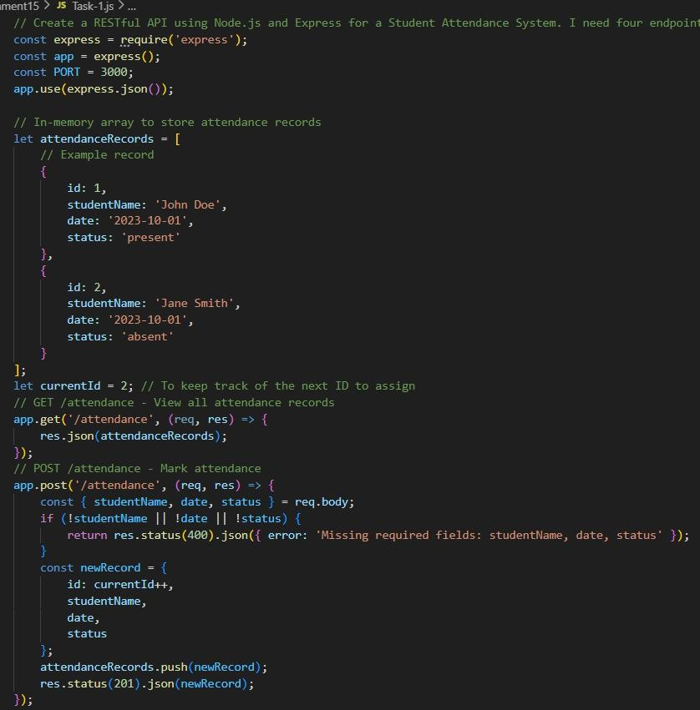

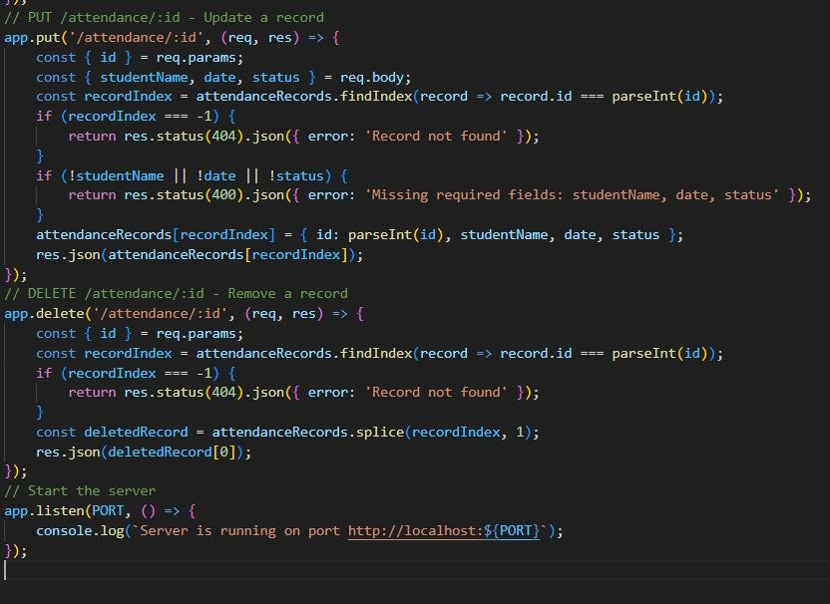
Output:-
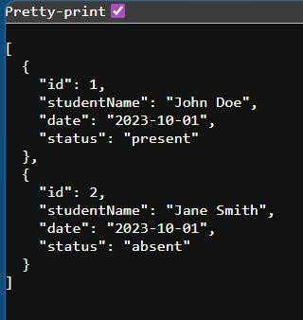

Justification:-
This code sets up a simple RESTful API for managing student attendance records using Node.js and Express. It includes endpoints for viewing all records, adding new records, updating existing records, and deleting records. The data is stored in an in-memory array, which is suitable for testing and development purposes. Basic error handling is implemented to ensure that required fields are provided and that operations are performed on existing records. All responses are returned in JSON format for consistency and ease of use with front-end applications.

Task 2 – Inventory Management API Task:
Develop a REST API for warehouse inventory management. Instructions:
- Endpoints required:
- GET /inventory → List all items
- POST /inventory → Add new item
- PUT /inventory/{id} → Update stock quantity
- DELETE /inventory/{id} → Remove an item
- Implement validation for stock values. Expected Output:
- API capable of managing inventory stock levels.

Prompt:-
//create a RESTful API using Node.js and Express for Warehouse Inventory Management that stores items with an ID, name, and stock quantity in an in-memory array. Provide a GET
/inventory endpoint to list all items, a POST /inventory endpoint to add new items, a PUT
/inventory/:id endpoint to update the stock quantity, and a DELETE /inventory/:id endpoint to remove items. Include a validation check to ensure that stock quantity cannot be updated to a negative number and return a 400 error if it is.

Code:-
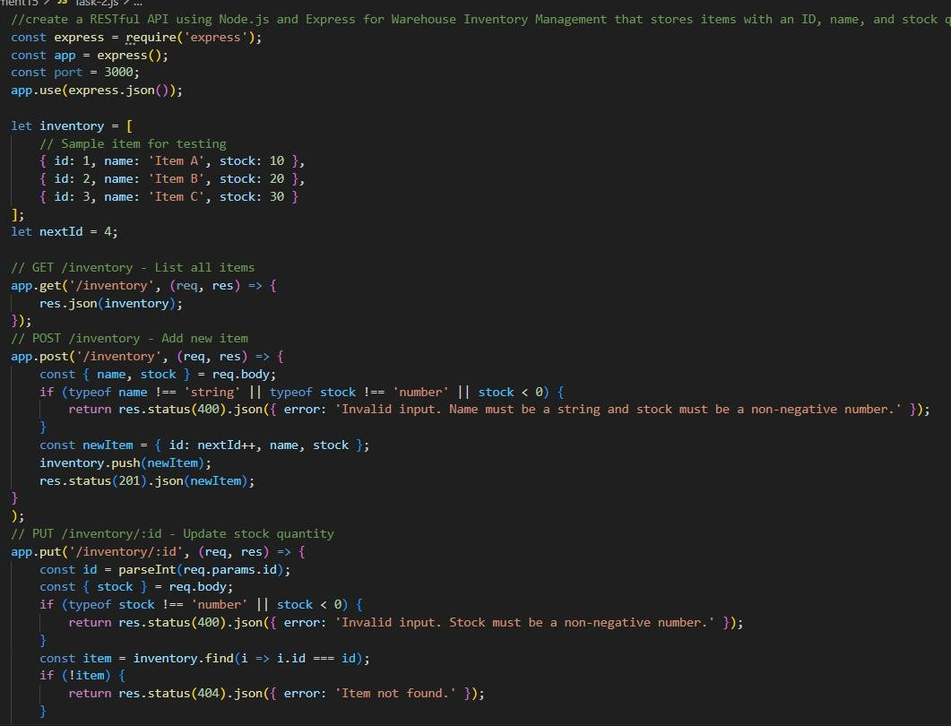

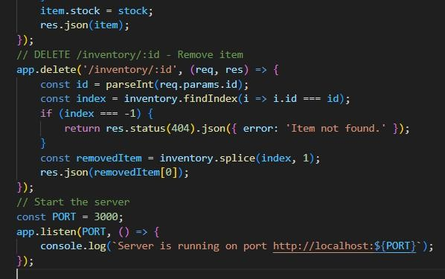

Output:-
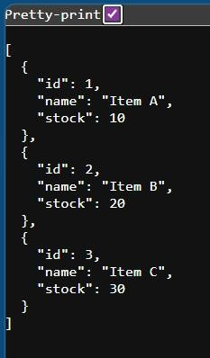

Justification:
The code implements a RESTful API for Warehouse Inventory Management using Node.js and Express. It provides endpoints for listing all items, adding new items, updating stock quantity, and removing items. The code includes validation checks to ensure that stock quantity cannot be negative and returns appropriate error messages for invalid input or when an item is not found.

Task 3 – Hotel Room Booking API Task:
Develop a RESTful API for hotel room booking. Instructions:
- Endpoints required:
- GET /rooms → View available rooms
- POST /rooms/book → Book a room
- GET /rooms/{id} → View booking details
- DELETE /rooms/{id} → Cancel booking
- Implement error handling for unavailable rooms. Expected Output:
- API simulating hotel room booking operations.

Prompt:-
Create a RESTful API for a Hotel Room Booking system using Node.js and Express that manages an array of rooms containing an ID, room number, and booking status. Develop a GET /rooms endpoint that returns only available rooms, a POST /rooms/book endpoint to book a specific room, a GET /rooms/:id endpoint to view specific booking details, and a DELETE /rooms/:id endpoint to cancel a booking. Implement error handling to return a message if a user tries to book a room that is already occupied or does not exist.

Code:-
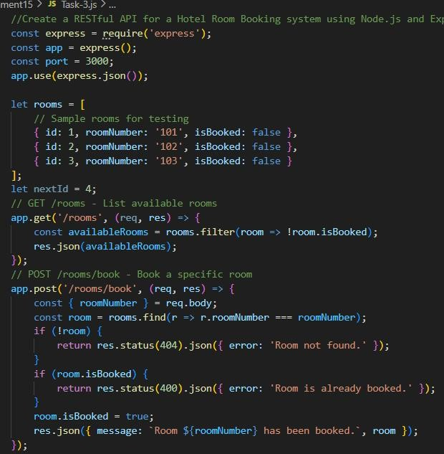

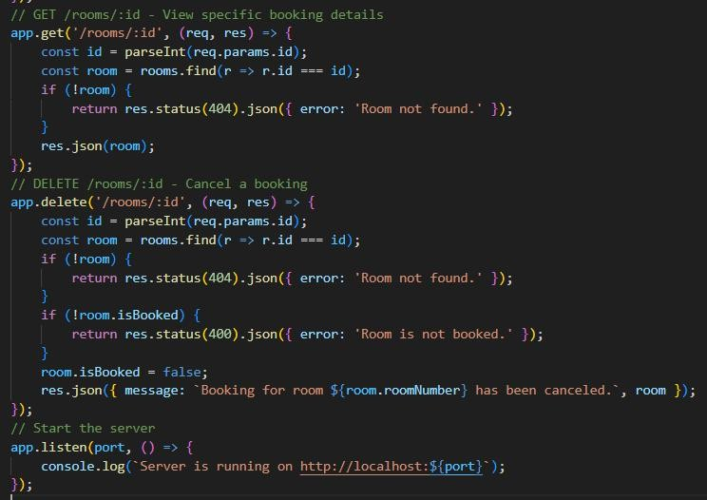
Output:-
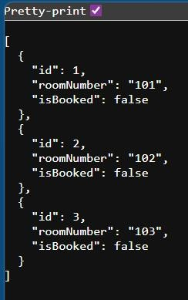
Justification:
This code implements a RESTful API for a Hotel Room Booking system using Node.js and Express. It provides endpoints to view available rooms, book a specific room, view booking details, and cancel a booking. The API includes error handling to ensure that users cannot book already occupied rooms or cancel bookings for rooms that are not currently booked and returns appropriate JSON responses for each operation.

Task 4 – Online Voting API Task:
Create a RESTful API for an online voting system. Instructions:
- Endpoints required:
- GET /candidates → List candidates
- POST /vote → Cast a vote
- GET /results → View voting results
- Ensure one vote per user using in-memory validation. Expected Output:
- API simulating a secure online voting process.

Prompt:-
Develop a RESTful API for an Online Voting System using Node.js and Express that manages a list of candidates and tracks user participation to ensure one vote per person. Include a GET /candidates endpoint to list all candidates, a POST /vote endpoint that accepts a userId and candidateId while checking an in-memory list to prevent duplicate voting, and a GET /results endpoint to display the current vote totals. If a user attempts to vote a second time, the API should return a message stating they have already voted.

Code:-
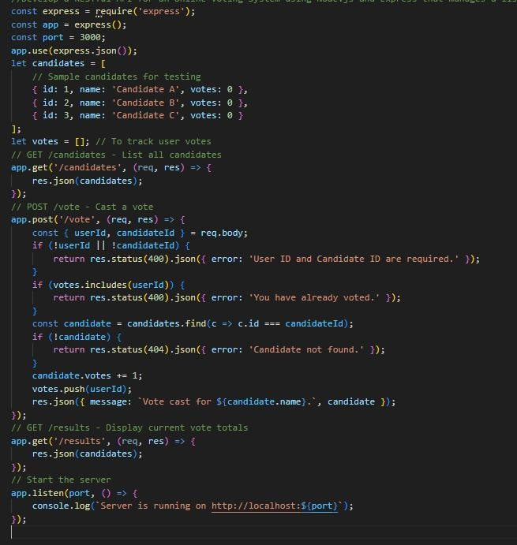

Output:-
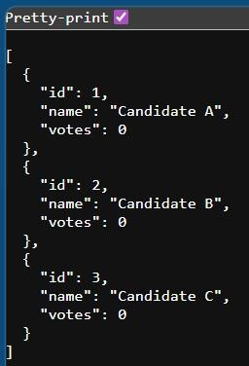
Justification:
This code implements a RESTful API for an Online Voting System using Node.js and Express. It provides endpoints to list candidates, cast votes while ensuring one vote per user, and display current vote totals. The API includes error handling to prevent duplicate voting and returns appropriate JSON responses for each operation.

Task 5 – Teacher Management API Task:
Develop a RESTful API to manage teacher records. Instructions:
- Endpoints required:
- GET /teachers → List all teachers
- POST /teachers → Add a new teacher
- PUT /teachers/{id} → Update teacher details
- DELETE /teachers/{id} → Remove a teacher
- Ensure proper error handling and JSON responses. Expected Output:
- Functional API for managing teacher information.

Prompt:-
Build a RESTful API for Teacher Management using Node.js and Express that allows for full CRUD operations on teacher records consisting of ID, name, subject, and department.
Implement a GET /teachers endpoint to view the list, a POST /teachers endpoint to add a new record, a PUT /teachers/:id endpoint to update teacher details, and a DELETE /teachers/:id endpoint to remove a record. Ensure the API returns proper JSON responses and 404 error messages if a requested teacher ID is not found in the system.

Code:-
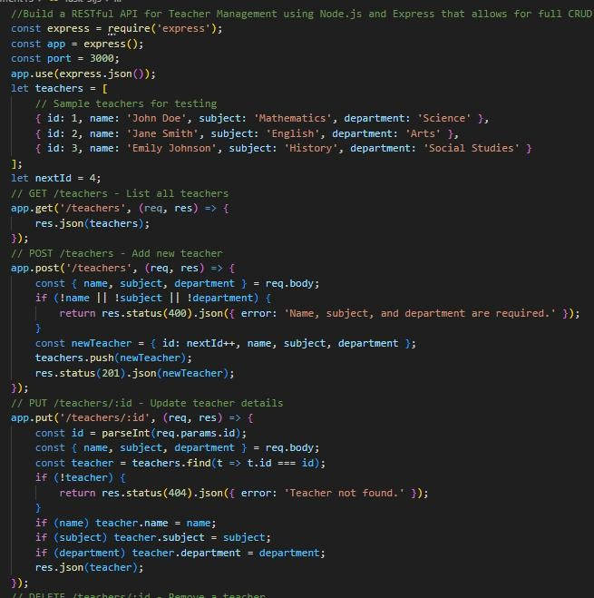
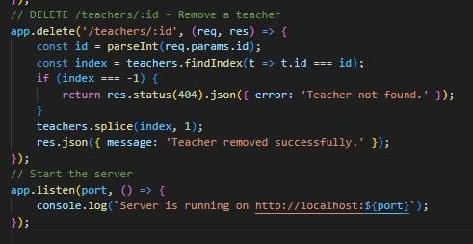

Output:-
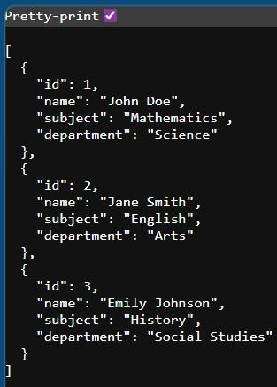
Justification:
This code implements a RESTful API for Teacher Management using Node.js and Express. It provides endpoints to view the list of teachers, add new teacher records, update existing teacher details, and remove teacher records. The API includes error handling to ensure that required fields are provided when adding or updating a teacher and returns appropriate JSON responses for each operation, including 404 errors when a requested teacher ID is not found in the system.

